- Customer Relationship Management (CRM) Dashboard:

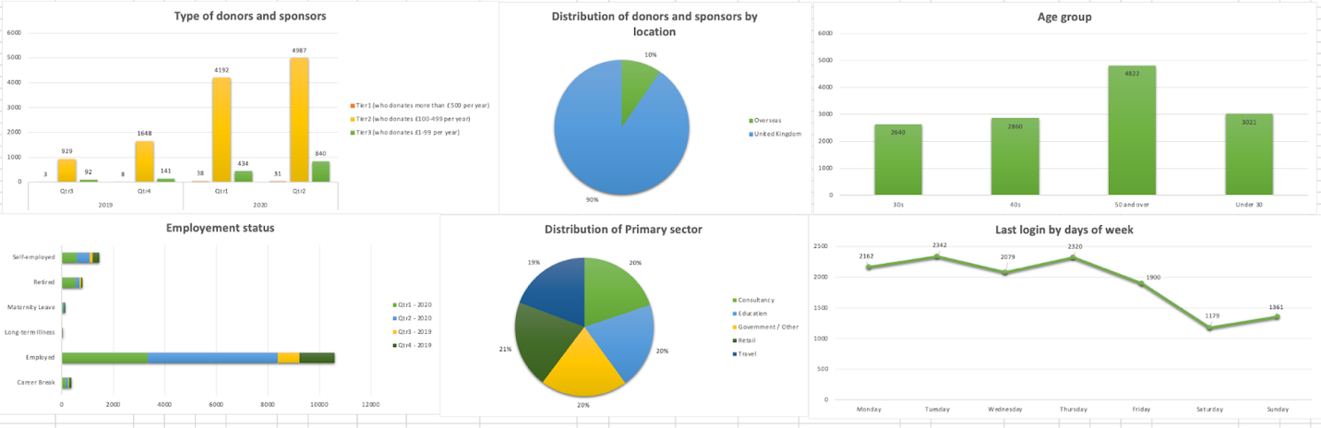

- Facebook Dashboard

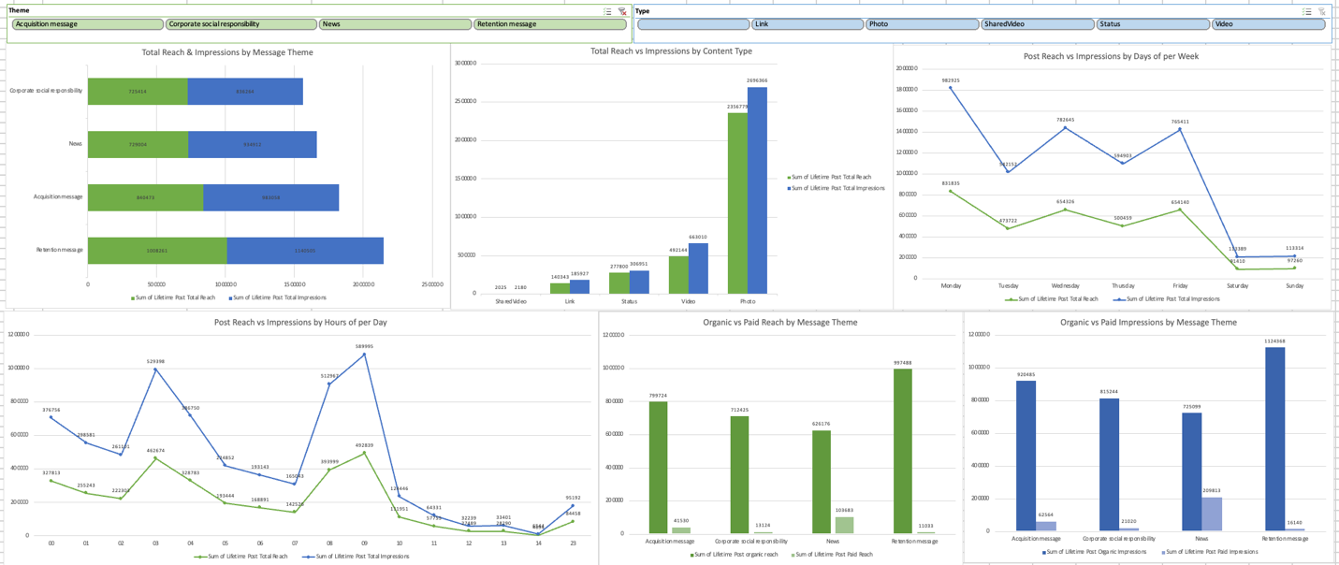

- Twitter Dashboard

